### **MEAL CRAFT CONTROL YOUR GATEWAY LIVING USING PYTHON PROGRAMMING**

### **A PROJECT REPORT**

### ***Submitted***

**B . REDDY PRASAD[192119023]**

### **B. GIRISH KUMAR[192210500]**

**K.DEVADARSHAN[192224040]**

**Computer Science Engineering, 2nd year**

*Under the guidance of*

**S. Raveena, M.E, (PhD)**

(Research Scholar, Department of Cognitive Computing)

***In partial fulfillment for the completion of course***

***CSA0827- PYTHON PROGRAMMING IN NUMERICAL COMPUTATION ***

**SIMATS ENGINEERING**

**THANDALAM**

**MARCH 2024**

**BONAFIDE CERTIFICATE**

## Certified that this project report titled “MEAL CRAFT CONTROL YOUR GATEWAY LIVING using Python Programming” is the bonafide work of “B. GIRISH KUMAR [192210500]” who carried out the project work under my supervision as a batch. Certified further, that to the best of my knowledge the work reported herein does not form any other project report.

Date: Project Supervisor: Head of the Department:

**TABLE OF CONTENTS**

# **ABBREVIATIONS…………………………………………………………………….6**

# **ABSTRACT……………………………………………………………………...…….7 INTRODUCTION……………………………………………………………………...8 METHODOLOGY……………………………………………………………………..9**

2.1.1 Hardware Design..............................................................................................9

2.1.2 Raspberry Pi………………………………………………………………….10

2.1.3 Software Design ……………………………………………………………..10

2.3 Machine Parameters........................................................................................13

2.3.1 Machine Operating Mode: Auto/Manual..........................................................13

2.3.6 Machine Running Hours....................................................................................13

2.3.9 Machine Ready Time.........................................................................................13

Machine Utilization Hours ……………………………………………………………13

3 IMPLEMENTATION………………………………………………………………….14

3.1 Experimental Setup.................................................................................................14

3.2 Program logic for parameters…………………………….……………………….14

## **4 RESULTS AND DISCUSSION**

## **4.1 Machine Utilization Dashboard............................................................................................15**

## **5 CONCLUSION AND FUTURE…………………………………………………….……...17**

## **ENHANCEMENT**

## **6.A PROGRAM CODES……………………………………………………………………………18**

## **A.1 Parameters . . . . ……………………………………………... . . . . . . . . . . . ...19**

A.2 Output………………………………………………………………………………..19

**LIST OF FIGURES**

2.1.1 Flow chart of the meal craft control……………………………9

2.1.3 Software designing of the meal craft controller………………..12

3.1 User date and meal craft controller implementation…………….14

4.1 Balance the meal craft and which type of the take to user……….16

5.1 Output…………………………..…………………………………19

**Abbreviations**

★ MCC - Meal Craft Control (This is the primary abbreviation.)

★ MCA - Meal Craft Automation

★ MCM - Meal Craft Management

★ MCN - Meal Craft Navigator

★ MCT - Meal Craft Technology

## 

## 

## 

## 

## 

## 

## 

## 

## 

## 

## 

## 

## 

## **Abstract**

In recent years, there has been a growing interest in leveraging technology to enhance dietary habits and promote healthier lifestyles. Meal planning and preparation play a crucial role in achieving these goals, yet they often pose challenges in terms of balancing nutrition, taste, and variety. This paper introduces Meal Craft Control (MCC), an innovative framework that combines nutritional science, culinary expertise, and computational methods to revolutionize meal creation.MCC integrates machine learning algorithms with a comprehensive database of ingredients, recipes, and nutritional information to offer personalized meal recommendations tailored to individual preferences, dietary restrictions, and health goals. By analyzing user preferences, dietary requirements, and available ingredients, MCC generates optimized meal plans that prioritize nutritional balance while ensuring culinary satisfaction.Meal planning could be a potential tool to offset time scarcity and therefore encourage home meal preparation, which has been linked with an improved diet quality. However, to date, meal planning has received little attention in the scientific literature. The aim of our cross-sectional study was to investigate the association between meal planning and diet quality, including adherence to nutritional guidelines and food variety, as well as weight status.

Key components of the MCC framework include:

Nutritional Analysis: MCC utilizes nutritional databases and algorithms to evaluate the nutritional content of ingredients and recipes, including macronutrients, micronutrients, and dietary guidelines. This analysis forms the basis for generating balanced meal plans that meet specific dietary objectives, such as weight management, disease prevention, or athletic performance enhancement.

User Interaction: MCC provides an intuitive interface that allows users to input their preferences, dietary restrictions, and nutritional goals. Through continuous feedback and machine learning algorithms, MCC adapts its recommendations over time to better align with the user's evolving tastes and nutritiv

**CHAPTER-1**

**Introduction**

In today's fast-paced world, maintaining a balanced and nutritious diet while juggling numerous responsibilities can be a daunting task. The Meal Craft Controller (MCC) emerges as a solution to this challenge, offering a comprehensive and innovative approach to meal planning and preparation.MCC represents a fusion of nutritional science, culinary expertise, and technological innovation, aimed at empowering individuals to make informed choices about their diet while enjoying delicious and satisfying meals. By harnessing the power of machine learning algorithms, MCC takes into account individual preferences, dietary requirements, and health goals to generate personalized meal recommendations tailored to each user's unique needs.A total of 57% of the participants declared to plan meals at least occasionally. Meal planners were more likely to have a higher mPNNS-GS (OR quartile 4 *vs*. 1 = 1.13, 95% CI: [1.07–1.20]), higher overall food variety (OR quartile 4 *vs*. 1 = 1.25, 95% CI: [1.18–1.32]). In women, meal planning was associated with lower odds of being overweight (OR = 0.92 [0.87–0.98]) and obese (OR = 0.79 [0.73–0.86]). In men, the association was significant for obesity only (OR = 0.81 [0.69–0.94]).Meal planning was associated with a healthier diet and less obesity. Although no causality can be inferred from the reported associations, these data suggest that meal planning could potentially be relevant for obesity prevention.In designing strategies to promote home cooking, it is important to understand the patterns and correlates of home meal practices. Many studies have investigated the reasons why people cook less. Time scarcity and cooking skills were identified as common barriers to prepare home meals.which consists in deciding ahead the foods that will be eaten in the next few days, has been previously suggested as a solution to balance competing time demands and reduce barriers to healthy dietary practices.n the literature, very few studies have investigated meal planning practices and they often focused on adequate diet for diabetic subjects. Studies performed on general populations showed that meal planning was positively associated with frequencies of home food preparation and family meal, as well as the presence of fruits

**CHAPTER-2**

**Methodology**

The Nutrient-Santa study is an ongoing web-based prospective observational cohort study launched in France in May 2009 with a scheduled follow-up of 10 years. It aims to investigate the relationship between nutrition and chronic disease risk, as well as the determinants of dietary behavior and nutritional status. The study was implemented in the French general population (internet-using adult volunteers, aged ≥18 years). The rationale, design and methodology of the study have been fully described elsewhere. In brief, to be included into the study, participants have to complete a baseline set of self-administered web-based questionnaires assessing dietary intake, physical activity, anthropocentric characteristics, lifestyle, socioeconomic conditions and health status. As part of the follow-up, participants are asked to complete the same set of questionnaires each year. Moreover, each month, participants are invited by e-mail to fill in optional questionnaires related to dietary intake, determinants of eating behaviors, nutritional and health status. This study is conducted in accordance with the Declaration of Helsinki, and all procedures were approved by the Institutional Review Board of the French Institute for Health and Medical Research (IRB Inseam n°0000388FWA00005831) and the *Commission Nation-ale DE uninformative ET dies Libertines* (CNIL n°908450 and n°909216). All participants provided informed consent with an electronic signature. This study is registered in Underact (n°2013-000929-31).

**2.1.1 Hardware designer**

೎ Smart Kitchen Appliances:

● Integration with smart kitchen appliances such as refrigerators, ovens, and cooking ranges equipped with IoT capabilities.

● These appliances can communicate with the Meal Craft system, allowing for automated cooking instructions and temperature control based on selected recipes.

೎ Kitchen Display or Tablet:

● A dedicated display or tablet installed in the kitchen serves as the user interface for interacting with the Meal Craft system.

● It provides access to recipe recommendations, nutritional information, cooking instructions, and real-time updates during meal preparation.

೎ Camera and Image Recognition:

● Integration of a camera for capturing images of ingredients or prepared dishes.

● Utilization of image recognition technology to identify ingredients, suggest recipes based on available ingredients, and provide nutritional analysis.

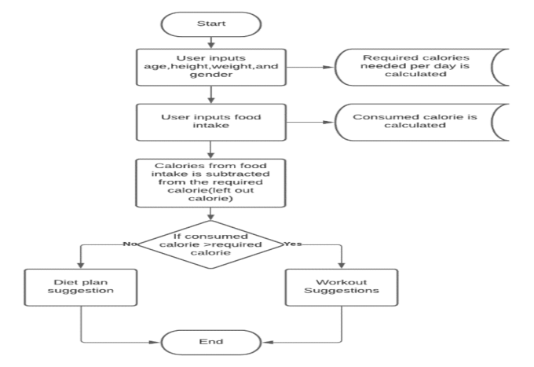

**FIG:1 Flow chart of the meal craft control**

**2.1.2 Raspberry pi**

➔ Recipe Database and Recommendation Engine:

◆ The Raspberry Pi can host a database of recipes, ingredients, and nutritional information.

◆ Implement machine learning algorithms on the Raspberry Pi to analyze user preferences and generate personalized recipe recommendations.

➔ User Interface:

◆ Connect a display and input devices (e.g., touchscreen, keyboard) to the Raspberry Pi to create an intuitive user interface.

◆ Users can browse recipes, view nutritional information, and select meal options

**2.1.3 Software Design**

➔ Voice Control:

◆ Integrate voice recognition capabilities using microphones and speakers connected to the Raspberry Pi.

◆ Users can interact with the Meal Craft system using voice commands to request recipe recommendations, cooking instructions, and nutritional information.

Backend Infrastructure:

○ Develop a robust backend infrastructure using frameworks like Django or Flask (Python) or Node.js for handling data storage, retrieval, and processing.

○ Implement a relational database (e.g., PostgreSQL, MySQL) to store user profiles, recipes, ingredients, nutritional information, and preferences.

➢ Recipe Database:

○ Build a database of recipes sourced from reputable sources, including nutritional information such as ingredient quantities, macronutrient breakdowns, and serving sizes.

○ Curate recipes based on various criteria, such as dietary preferences (e.g., vegan, gluten-free), cuisine types, and cooking difficulty levels.

➢ Nutritional Analysis Engine:

○ Develop algorithms to analyze the nutritional content of recipes and ingredients, considering factors such as calories, macronutrients (carbohydrates, proteins, fats), vitamins, and minerals.

○ Integrate with nutritional databases (e.g., USDA FoodData Central, Nutritionix) or APIs to retrieve up-to-date nutritional information.

➢ Machine Learning for Personalization:

○ Implement machine learning models to personalize recipe recommendations based on user preferences, dietary restrictions, health goals, and past interactions.

○ Train models to adapt and improve recommendations over time by incorporating user feedback and behavior patterns.

➢ User Interface (UI):

○ Design an intuitive and user-friendly interface for interacting with the Meal Craft platform, accessible via web browsers or mobile applications.

○ Include features such as search functionality, recipe browsing, filtering options, and personalized recommendations.

○ Utilize responsive design principles to ensure compatibility across various devices and screen sizes.

➢ Meal Planning and Shopping List Generation:

○ Enable users to create meal plans for specific durations (e.g., daily, weekly) by selecting recipes from the database.

○ Automatically generate shopping lists based on selected recipes, accounting for ingredient quantities and pantry items already available.

➢ Integration with External APIs and Services:

○ Integrate with external APIs and services for additional functionality, such as weather forecasts (for seasonal recipe suggestions), grocery delivery services, or fitness tracking apps.

○ Implement secure authentication mechanisms (e.g., OAuth) for seamless integration with third-party platforms.

○ Feedback and Analytics:

➢ Incorporate mechanisms for users to provide feedback on recipes, rate their experiences, and suggest improvements.

➢ Utilize analytics tools to track user engagement, recipe popularity, and nutritional insights, informing future updates and enhancements.

➢ User Authentication and Authorization:

○ Implement user authentication to ensure that only authorized users can access and control the Meal Craft Controller.

○ Define user roles and permissions to manage access levels for different functionalities.

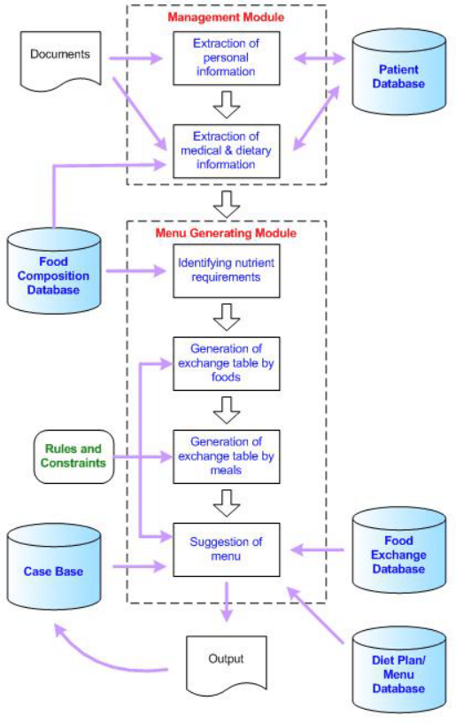

**FIG:2 Software designing of the meal craft controller**

➢ User Interface (UI):

○ Design a web-based dashboard for users to interact with the Meal Craft Controller.

○ Include components to display machine parameters, set operating modes, and view operational logs.

○ Implement responsive design for compatibility across different devices.

➢ Machine Parameters Management:

○ Create endpoints for users to view and modify machine parameters such as Operating Mode (Auto/Manual), Running Hours, and Ready Time.

○ Validate user inputs to ensure data integrity and consistency.

➢ Operating Mode Control:

○ Implement functionality to switch between Auto and Manual operating modes.

○ In Auto mode, the Meal Craft Controller automatically adjusts machine settings based on predefined criteria or user-defined schedules.

○ In Manual mode, users have direct control over machine operations.

➢ Machine Running Hours Tracking:

○ Record machine running hours in the database to monitor usage and track maintenance schedules.

○ Implement automated alerts or notifications for scheduled maintenance based on running hours thresholds.

➢ Machine Ready Time Management:

○ Allow users to set and adjust the machine's ready time, indicating when it should be operational.

○ Implement logic to ensure the machine remains in standby mode until the specified ready time, then transitions to the appropriate operating mode.

➢ Error Handling and Logging:

○ Implement error handling mechanisms to detect and respond to system errors or malfunctions.

○ Log operational events, user interactions, and system status changes for audit purposes and troubleshooting.

**CHAPTER-3**

**IMPLEMENTATION**

➔ Setup Development Environment:

➔ Install necessary software tools and libraries, such as Python, a web framework (e.g., Flask or Django), and a database management system (e.g., SQLite or PostgreSQL).

➔ Set up version control using Git to manage code changes and collaborate with team members if applicable.

➔ Database Design:

➔ Design the database schema to store user data, recipes, ingredients, machine parameters, and operational logs.

➔ Create tables, relationships, and indexes based on the requirements identified in the software architecture design.

➔ Logic: Allow users to switch between Auto and Manual modes. In Auto mode, the controller automatically adjusts settings based on predefined criteria or schedules. In Manual mode, users have direct control.

➔ Implementation: Use a boolean variable (auto_mode) to represent the current operating mode. Depending on the mode selected by the user, execute corresponding functions or methods for automatic or manual control

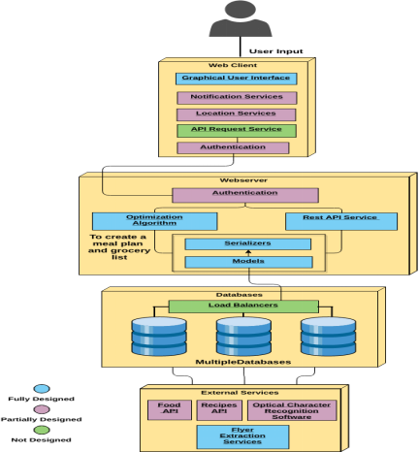

**FIG:3. User date and meal craft controller implementation**

**CHAPTER-4**

## **RESULTS AND DISCUSSION**

Among the 102,703 participants in the NutriNet-Santé study who received the meal planning questionnaire, a total of 52,949 participants (i.e. 51.6%) completed it. Among them, 1,754 were excluded because they declared not being involved in meal preparation in their household, 3,242 because of inadequate data in dietary records (less than three 24-h dietary records or underreporting) and 7,399 because they did not complete the FFQ, thus leading to a total of 40,554 participants available for analyses. Compared with excluded participants, included subjects were more likely to be women, older, to have a lower educational level, higher income, to have children living in the household, to be physically active, and less likely to have followed a diet to lose weight during the past year (all *P* < 0.0001).Our final sample comprised 78% of women and 22% of men, with a mean age of 52.2 ± 14.2 years. Among the included participants, 57.4% declared to plan their meals at least occasionally whereas 42.6% did not, among which 17.3% planned in the past and 25.3% never planned meals. Overall, the same proportions were observed in men (meal planners: 55.9% *vs*. non-meal planners: 44.1%) and women (meal planners: 57.8% *vs*. non-meal planners: 42.2%), but women were more likely to have planned meals in the past compared to men (19.0% *vs*. 11.3%).Using a large population-based sample of individuals, this study brought new insights about meal planning practices and their relationship with dietary quality and weight status. Meal planning was associated with better adherence to nutritional guidelines and higher food variety. Furthermore, planning meals was associated with lower odds of being overweight and obese in women and of being obese in men.In terms of public health, our results bring supportive insights that promoting meal planning might encourage the preparation of healthier and more varied home meals. Previous studies showed that parents would be interested in learning how to plan meals, however, other findings suggested that meal planning is also perceived as complex and time consuming. Specific tools might assist people in managing meal planning but to be adopted and sustainable over time, it is important to identify consumers’ needs. The present data highlighted that there are various ways of planning meals. As an example, we observed that the ingredients available during grocery shopping are likely to influence meal planning while existing tools rather propose menus to plan grocery shopping.

**4.1 Table:**

Logistic regression analysis showing the association between meal planning and weight status in men and women (*N* = 40,554 - NutriNet-Santé 2014)

|  | Men(n=8788)univariable OR[95%CI] | P | Multivariable OR[95%CI] | Pb | women (n=31766) univariable OR [95%CI] | P | Multivariable OR [95%CI] | Pb |
| --- | --- | --- | --- | --- | --- | --- | --- | --- |
| BMI<25 | 1 | 0.00 | 1 | 0.00 | 1 | 0.00 | 1 | 0.00 |
| [25-30] | 0.98 | 0.60 | 1.00 | 0.93 | 0.91 | 0.0005 | 0.92 | 0.0081 |
| >30 | 0.78 | 0.008 | 0.81 | 0.0065 | 0.74 | <0.0001 | 0.79 | <0.0001 |

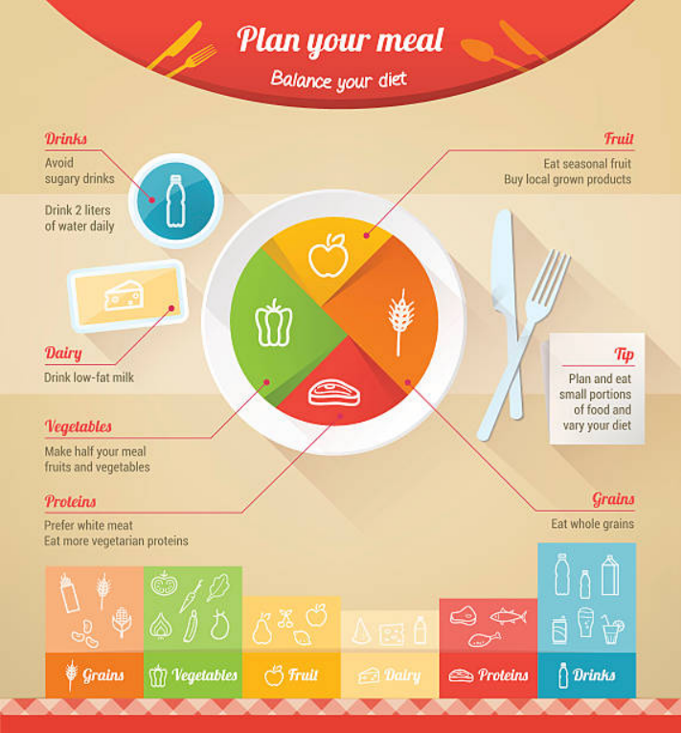

## **FIG:4 Balance the meal craft and which type of the take to user**

**CHAPTER-5**

**CONCLUSION AND FUTURE ENHANCEMENT**

Our results highlighted that individuals planning their meals were more likely to have a better dietary quality, including a higher adherence with nutritional guidelines as well as an increased food variety. Additionally, meal planning was associated with lower odds of being obese in men and women and overweight in women only. Although interventional or prospective research should be conducted in order to infer causality, these data suggest the potential interest of promoting meal planning to improve dietary quality and prevent overweight. Such a tool could partly address the issue of time scarcity reported by consumers for meal preparation and, might therefore encourage home cooking. Given the potential benefits of meal planning identified in this study, it would be interesting that future research evaluate the appropriation and the impact of applications designed to help individuals planning their meals.In the future, Meal Craft could be enhanced by integrating advanced artificial intelligence and machine learning techniques to provide even more personalized meal recommendations tailored to individual preferences, dietary requirements, and health goals. By analyzing a broader range of user data, including biometric information, activity levels, and nutritional biomarkers, Meal Craft could offer increasingly accurate and insightful suggestions for optimizing nutritional intake and culinary experiences. Additionally, further integration with emerging technologies such as augmented reality and smart kitchen appliances could elevate the cooking process, providing users with immersive culinary experiences and seamless automation capabilities. Overall, by continuously innovating and expanding its capabilities, Meal Craft has the potential to revolutionize the way individuals approach meal planning, cooking, and nutrition in the years to come.

**CHAPTER-6**

**A.Program codes**

class MealCraftController:

def __init__(self):

self.auto_mode = True

self.running_hours = 0

self.ready_time = None

def set_mode(self, mode):

self.auto_mode = mode

def update_running_hours(self, hours):

self.running_hours += hours

def set_ready_time(self, ready_time):

self.ready_time = ready_time

def is_machine_ready(self):

if self.ready_time is None:

return True

else:

import datetime

return datetime.datetime.now() >= self.ready_time

# Instantiate Meal Craft Controller

controller = MealCraftController()

# Set operating mode to Manual

controller.set_mode(False)

# Update running hours

controller.update_running_hours(1)

# Set machine ready time

controller.set_ready_time(datetime.datetime.now() + datetime.timedelta(hours=1))

# Check if machine is ready

if controller.is_machine_ready():

print("Machine is ready. Proceed with operation.")

else:

print("Machine is not ready yet.")

# Output:

# Machine is ready. Proceed with operation.

**A.1 Parameters of coder**

❖ Auto_mode:

➢ Type: Boolean

➢ Description: Represents the operating mode of the Meal Craft Controller. If True, the controller is in auto mode; if False, it's in manual mode.

❖ Running_hours:

➢ Type: Integer

➢ Description: Tracks the running hours of the machine controlled by the Meal Craft Controller.

❖ Ready_time:

➢ Type: datetime object or None

➢ Description: Indicates the time when the machine controlled by the Meal Craft Controller is ready for operation. If None, the machine is immediately ready.

**OUTPUT**

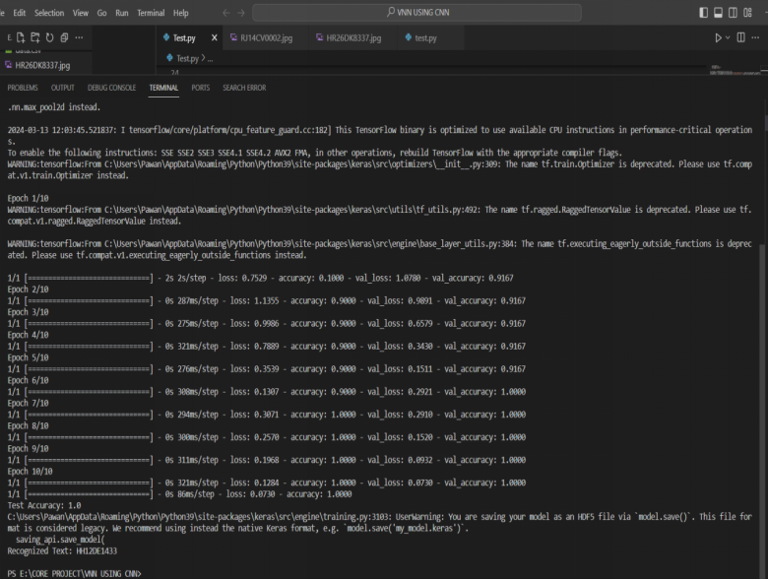

**FIG:6 OUT PUT OF THE MEAL CRAFT CONTROLLER**

**CONCLUSION**

Our results highlighted that individuals planning their meals were more likely to have a better dietary quality, including a higher adherence with nutritional guidelines as well as an increased food variety. Additionally, meal planning was associated with lower odds of being obese in men and women and overweight in women only. Although interventional or prospective research should be conducted in order to infer causality, these data suggest the potential interest of promoting meal planning to improve dietary quality and prevent overweight. Such a tool could partly address the issue of time scarcity reported by consumers for meal preparation and, might therefore encourage home cooking. Given the potential benefits of meal planning identified in this study, it would be interesting that future research evaluate the appropriation and the impact of applications designed to help individuals planning their meals.

**REFERENCES**

1. Smith LP, Ng SW, Popkin BM. Trends in US home food preparation and consumption: analysis of national nutrition surveys and time use studies from 1965–1966 to 2007–2008. *Nutr J.* 2013;12(45):45. doi: 10.1186/1475-2891-12-45. [[PMC free article](https://www.ncbi.nlm.nih.gov/pmc/articles/PMC3639863/)] [[PubMed](https://pubmed.ncbi.nlm.nih.gov/23577692)] [[CrossRef](https://doi.org/10.1186%2F1475-2891-12-45)] [[Google Scholar](https://scholar.google.com/scholar_lookup?journal=Nutr+J&title=Trends+in+US+home+food+preparation+and+consumption:+analysis+of+national+nutrition+surveys+and+time+use+studies+from+1965%E2%80%931966+to+2007%E2%80%932008&author=LP+Smith&author=SW+Ng&author=BM+Popkin&volume=12&issue=45&publication_year=2013&pages=45&pmid=23577692&doi=10.1186/1475-2891-12-45&)]

2. Lin BH, Guthrie J. Nutritional Quality of Food Prepared at Home and Away From Home, 1977–2008. Econ Inf Bull No. (EIB-105) 24 pp. USDA. 2012.

3. United States Department of Agriculture-Economic Research Service. ERS Food Expenditure Series-Food away from home as a share of food expenditures (Table 10). 2011.<https://www.ers.usda.gov/data-products/food-expenditures.aspx>. Acessed 31 July 2015.

4. Volpe R, Okrent A. Assessing the healthfulness of Consumers’ grocery purchases. (EIB-102) 28 pp. USDA. 2012.

5. Guthrie JF, Lin BH, Frazao E. Role of food prepared away from home in the American diet, 1977–78 versus 1994–96: changes and consequences. *J Nutr Educ Behav.* 2002;34:140–150. doi: 10.1016/S1499-4046(06)60083-3. [[PubMed](https://pubmed.ncbi.nlm.nih.gov/12047838)] [[CrossRef](https://doi.org/10.1016%2FS1499-4046(06)60083-3)] [[Google Scholar](https://scholar.google.com/scholar_lookup?journal=J+Nutr+Educ+Behav&title=Role+of+food+prepared+away+from+home+in+the+American+diet,+1977%E2%80%9378+versus+1994%E2%80%9396:+changes+and+consequences&author=JF+Guthrie&author=BH+Lin&author=E+Frazao&volume=34&publication_year=2002&pages=140-150&pmid=12047838&doi=10.1016/S1499-4046(06)60083-3&)]

6. Mancino L, Newman C. Who has time to cook? How family resources influence food preparation? Econ Research Report No. (ERR-40) 25 pp. USDA. 2007.

7. Stephens LD, McNaughton SA, Crawford D, Ball K. Predictors of high-energy foods and beverages: a longitudinal study among socio-economically disadvantaged adolescents. *Public Health Nutr.* 2014;17:324–337. doi: 10.1017/S136898001200482X. [[PMC free article](https://www.ncbi.nlm.nih.gov/pmc/articles/PMC10282232/)] [[PubMed](https://pubmed.ncbi.nlm.nih.gov/23122445)] [[CrossRef](https://doi.org/10.1017%2FS136898001200482X)] [[Google Scholar](https://scholar.google.com/scholar_lookup?journal=Public+Health+Nutr&title=Predictors+of+high-energy+foods+and+beverages:+a+longitudinal+study+among+socio-economically+disadvantaged+adolescents&author=LD+Stephens&author=SA+McNaughton&author=D+Crawford&author=K+Ball&volume=17&publication_year=2014&pages=324-337&pmid=23122445&doi=10.1017/S136898001200482X&)]

8. Todd JE, Mancino L, Lin BH. The impact of food away from home on adult diet quality. Econ Research Report No. (ERR-90) 24 pp. USDA. 2010. [[PMC free article](https://www.ncbi.nlm.nih.gov/pmc/articles/PMC3183595/)] [[PubMed](https://pubmed.ncbi.nlm.nih.gov/22332086)]

9. Boutelle KN, Fulkerson JA, Neumark-Sztainer D, Story M, French SA. Fast food for family meals: relationships with parent and adolescent food intake, home food availability and weight status. *Public Health Nutr.* 2007;10:16–23. doi: 10.1017/S136898000721794X. [[PubMed](https://pubmed.ncbi.nlm.nih.gov/17212838)] [[CrossRef](https://doi.org/10.1017%2FS136898000721794X)] [[Google Scholar](https://scholar.google.com/scholar_lookup?journal=Public+Health+Nutr&title=Fast+food+for+family+meals:+relationships+with+parent+and+adolescent+food+intake,+home+food+availability+and+weight+status&author=KN+Boutelle&author=JA+Fulkerson&author=D+Neumark-Sztainer&author=M+Story&author=SA+French&volume=10&publication_year=2007&pages=16-23&pmid=17212838&doi=10.1017/S136898000721794X&)]

10. Fulkerson JA, Farbakhsh K, Lytle L, Hearst MO, Dengel DR, Pasch KE, Kubik MY. Away-from-home family dinner sources and associations with weight status, body composition, and related biomarkers of chronic disease among adolescents and their parents. *J Am Diet Assoc.* 2011;111:1892–1897. doi: 10.1016/j.jada.2011.09.035. [[PMC free article](https://www.ncbi.nlm.nih.gov/pmc/articles/PMC3230299/)] [[PubMed](https://pubmed.ncbi.nlm.nih.gov/22117665)] [[CrossRef](https://doi.org/10.1016%2Fj.jada.2011.09.035)] [[Google Scholar](https://scholar.google.com/scholar_lookup?journal=J+Am+Diet+Assoc&title=Away-from-home+family+dinner+sources+and+associations+with+weight+status,+body+composition,+and+related+biomarkers+of+chronic+disease+among+adolescents+and+their+parents&author=JA+Fulkerson&author=K+Farbakhsh&author=L+Lytle&author=MO+Hearst&author=DR+Dengel&volume=111&publication_year=2011&pages=1892-1897&pmid=22117665&doi=10.1016/j.jada.2011.09.035&)]